# REAL TIME RIVER WATER QUALITY MONITORING AND CONTROL SYSTEM

Category: **INTERNET OF THINGS**

A PROJECT REPORT

Submitted by

# CHARAN K

# AJAY P

# ARAVINDHAN D

# GOKUL R

FROM

# SRI VENKATESWARA COLLEGE OF ENGINEERING

In fulfillment of project in IBM-NALAYATHIRAN 2022

# TEAM ID: PNT2022TMID53558

INDEX

1. INTRODUCTION
   1. Project Overview
   2. Purpose 2.LITERATURE SURVEY
   3. Existing problem
   4. References
   5. Problem Statement Definition 3.IDEATION & PROPOSED SOLUTION
   6. Empathy Map Canvas
   7. Ideation & Brainstorming
   8. Proposed Solution
   9. Problem Solution fit 4.REQUIREMENT ANALYSIS
   10. Functional requirement
   11. Non-Functional requirements 5.PROJECT DESIGN
   12. Data Flow Diagrams
   13. Solution & Technical Architecture
   14. User Stories
2. PROJECT PLANNING & SCHEDULING
   1. Sprint Planning & Estimation
   2. Sprint Delivery Schedule
   3. Reports from JIRA 7.CODING & SOLUTIONING
   4. Feature 1
   5. Feature 2 8.TESTING
   6. Test Cases
   7. User Acceptance Testing 9.RESULTS

9.1 Performance Metrics 10.ADVANTAGES & DISADVANTAGES 11.CONCLUSION

1. FUTURE SCOPE
2. APPENDIX
   1. Source Code
   2. GitHub & Project Demo Link

# INTRODUCTION

* 1. **Project Overview:**

# River Water quality monitoring System

River water which is used as drinking water is a very precious commodity for all human beings.The system consists of several sensors which are used for measuring physical and chemical parameters of water. The parameters such as temperature, pH, and dissolved oxygen of the water can be measured. Using this system a person can detect pollutants from a water body from anywhere in the world.Current water quality monitoring system is a manual system with a monotonous process and is very time-consuming This paper proposes a sensorbased water quality monitoring system.

The main components of Wireless Sensor Network (WSN) include a micro-controller for processing the system, communication system for inter and intra node communication and several sensors Real-time data access can be done by using remote monitoring and Internet of Things (IoT) technology Data collected at the IBM cloud Server and verify them to trigger the actions to be performed.

# Purpose:

Water quality refers to chemical, physical biological and radio logical characteristics of water. It is a measure of the condition of water relative to the necessities of one or more bio-tic species and or to any human need or purposes .Water quality monitoring is defined as a sampling and analysis of the water in lake, stream, ocean and river and conditions of the water body. Smart water quality monitoring is a process of real-time monitoring and the analysis of water to identify changes in parameters based on the physical, chemical and biological characteristics.Monitoring water quality is clearly important: in our seas, our rivers, on the surface and in our ports, for both companies and the public.

It enables us to assess how they are changing, analyze trends and to inform plans and strategies that improve water quality and ensures that water meets its designated use.There are several indicators determining water quality. These include dissolved oxygen, turbidity, bio indicators, nitrates, pH scale and water temperature.Monitoring water quality helps to identify specific pollutants, a certain chemical, and the source of the pollution.There are many sources of water pollution: wastewater from sewage seeping into the water supply; agricultural practices (e.g., the use of pesticides and fertilizer); oil pollution, river and marine dumping, port, shipping and industrial activity.

Monitoring water quality and a water quality assessment regularly provides a source of data identify immediate issues – and their source.

* Identifying trends, short and long-term, in water quality.
* Data collected over a period of time will show trends, for example identifying increasing concentrations of nitrogen pollution in a river or an inland waterway. The total data will then help to identify key water quality parameters
* Environmental planning methods: water pollution prevention and management.
* Collecting, interpreting and using data is essential for the development of a sound and effective water quality strategy. The absence of real-time data will however hamper the development of strategies and limit the impact on pollution control. Using digital systems and programs for data collection and management is a solution to this challenge.

Monitoring water quality is a global issue and concern: on land and at sea. Within the European Union, the European Green Deal sets out goals for restoring biological biodiversity and reducing water pollution, as well as publishing various directives to ensure standards of water quality. Individual nation states, for example France, have also clear regulatory frameworks requiring the effective monitoring of water quality. In the United States, the Environmental Protection Agency (EPA) enforces regulations to address water pollution in each state. Across the world, countries increasingly understand the importance of effective water quality monitoring parameters and methods

# LITERATURE SURVEY

## Existing Problem:

Due to population growth, urbanization ,and climatic change ,competition for water resources is expected to increase, with a particular impact on agriculture, river water. Water will be suitableness to potable water monitoring compound spillage identification done rivers, remote estimation for swimming pools. It holds self- sufficient hubs that unite with the cloud to ongoing water control .The River water needed to be treated before it is used in agriculture feilds,hence the parameters affecting the quality of river-water need to be analysed and to be used for water treatement purpose.

## References:

1. K.S. Adu-Manu, C. Tapparello, W. Heinzelman, F.A. Katsriku, J.-D. Abdulai Water quality monitoring using wireless sensor networks: Current trends and future research directions ACM Transactions on Sensor Networks (TOSN) (2017).
2. S. Thombre, R.U. Islam, K. Andersson, M.S. Hossain IP based Wireless Sensor Networks : performance Analysis using Simulations and Experiments.Journal of Wireless Mobile Networks, Ubiquitous Computing, and Dependable Applications, 7 (2016).
3. M.Chitra, D. Sadhihskumar, R. Aravindh, M. Murali, R. Vaittilingame IoT based Water Flood Detection and Early Warning System.The collected information (data) from the water level sensor and temperature and humidity sensor passed to Thingview Android application in order to find the flow graph level of the water level in the river and temperature, humidity values and sends SMS to the registered contact mobile numbers (2020).
4. Dr.Geetha IoT based real time water quality monitoring system using smart sensor WQM is a cost effective and efficient system designed to monitor drinking water quality with the help of IOT(2020).

## Problem Statement:

The reduce the river water pollution and to monitor the parameters of river water and control measures can impact vegetation,health. The Real time analysis of Indicators of River water(Ph,salinity,nutrients,etc..,)

# IDEATION & PROPOSED SOLUTION

## Empathy Map :

An empathy map is a simple, easy-to-digest visual that captures knowledge about a user’s behaviours and attitudes. It is a useful tool to helps teams better understand their users.Creating an effective solution requires understanding the true problem and the person who is experiencing it. The exercise of creating the map helps participants consider things from the user’s perspective along with his or her goals and challenges.

## Ideation & Brainstorming:

Brainstorming provides a free and open environment that encourages everyone within a team to participate in the creative thinking process that leads to problem solving. Prioritizing volume over value, out-of-the-box ideas are welcome and built upon, and all participants are encouraged to collaborate, helping each other develop a rich amount of creative solutions. Use this template in your own brainstorming sessions so your team can unleash their imagination and start shaping concepts even if you're not sitting in the same room.

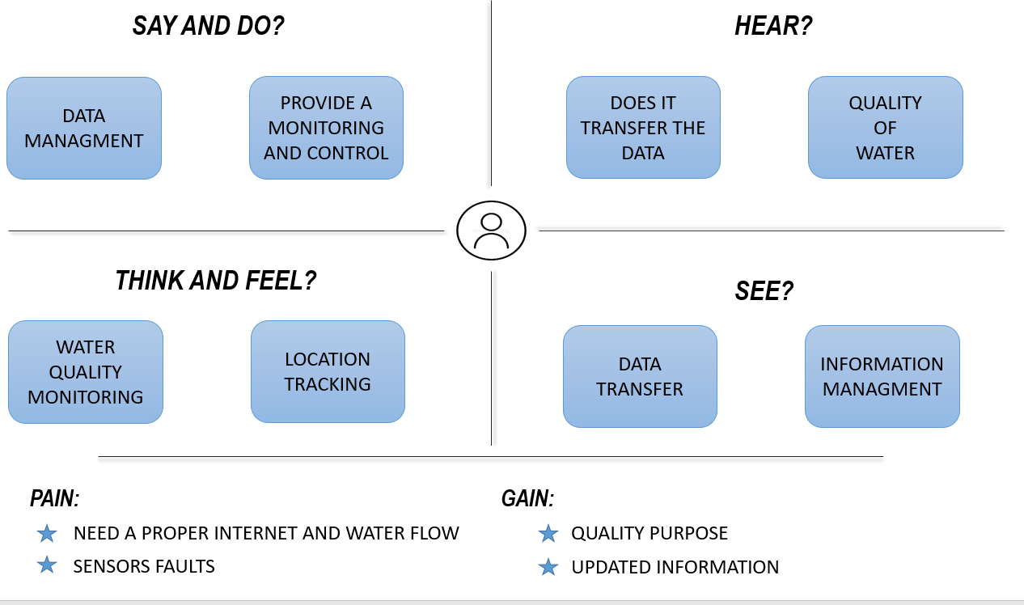

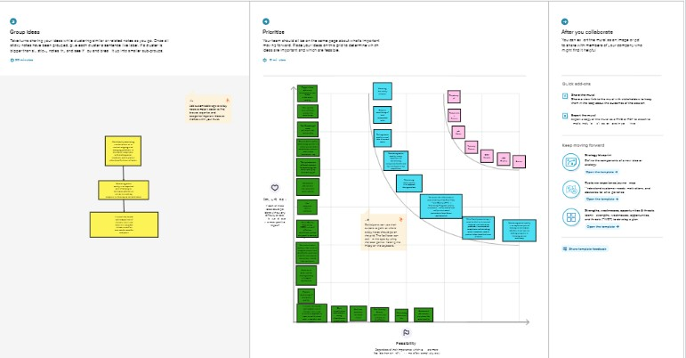

# Proposed Solution:

|  |  |  |
| --- | --- | --- |
| **S.No.** | **Parameter** | **Description** |
| 1. | Problem Statement (Problem to be solved) | Eutrophication, or the massive development of algae, causes pollution (monitoring and managing the quality of river  water |
| 2. | Idea / Solution description | Detecting dust particles, monitoring water PH, dissolved oxygen, and temperature, and changing authorities if water  quality is poor |
| 3. | Social Impact / Customer Satisfaction | Localities will not suffer as a result of poor water quality since they will be notified when  the water quality is not good |
| 4. | Business Model (Revenue Model) | Aeron systems provides water quality monitoring systems for industrial water treatment plants, river bodies, aqua  forming, and digital recorders |
| 5. | Scalability of the Solution | The assessment of realtime readings and continual monitoring helps in the preservation of water quality. |
| 6. | Novelty / Uniqueness | A web application may be used to monitor the quality of river water. The quality parameter will be tracked in real time with  standard measurements. |

**3.3 Proposed Solution:**

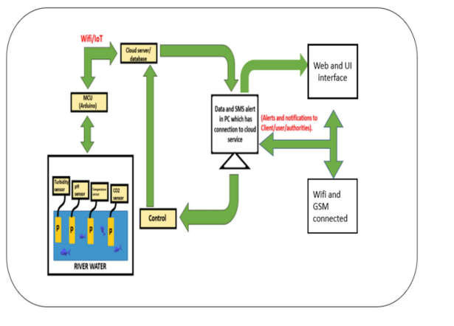

# 4 REQUIREMENT ANALYSI

* 1. **Functional Requirements:**

|  |  |  |
| --- | --- | --- |
| **FR No.** | **Functional Requirement (Epic)** | **Sub Requirement (Story / Sub-**  **Task)** |
| FR 1 | User Registration | Registration through Form Registration through Gmail  Registration through LinkedIN |
| FR 2 | User Confirmation | Confirmation via Email  Confirmation via OTP |
| FR 3 | Ultrasonic generator | Periodically the waves are generated to destroy algae in  the range of 25%,50%,100% |
| FR 4 | Ph level detection | To observe the water quality, Ph sensor is used and the signals  are conveyed to the Arduino |
| FR 5 | Turbidity detection | Turbidity sensor measures the purity of element or marshy utter in the water and the  signals are delivered to Arduino |

# Non-functional Requirements:

|  |  |  |
| --- | --- | --- |
| **FR No.** | **Non-Functional Requirement** | **Description** |
| NFR-1 | Usability | Monitors the flow and quality of ground water, and investigates surface- and  ground-water interactions. |
| NFR-2 | Security | The data and information are secured in the application by  using the application firewall. |
| NFR-3 | Reliability | The Real time sensor output values with future predicted data storage with output efficiency of 98%. It also gives certainty for aquaculture  safety |
| NFR-4 | Performance | The performance of system has higher efficiency and  environmental friendly. |
| NFR-5 | Availability | It is available in the form of  mobile UI 24 x 7 monitoring system. |
| NFR-6 | Scalability | The system has high scalability. Able to be changed in size or scale to  give the best output. |
| NFR-7 | Stability | The ability of the system to bring itself back to its stable configuration. The stability is  high. |
| NFR-8 | Efficiency | The monitoring system is highly efficient,high mobility  with consumption of power. |

**5. PROJECT DESIGN**

# Data Flow Diagrams:

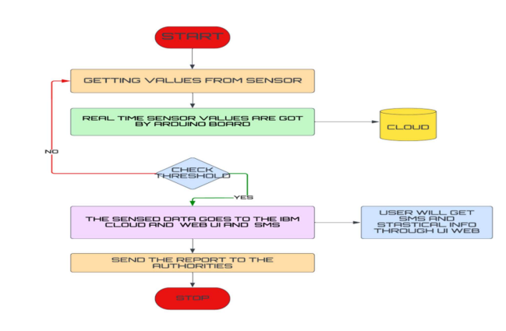Summary This code pattern explains how to build an IOT based river water monitoring and controlling system with some predefined values.

# SOLUTION AND TECHNICAL ARCHITECTURE

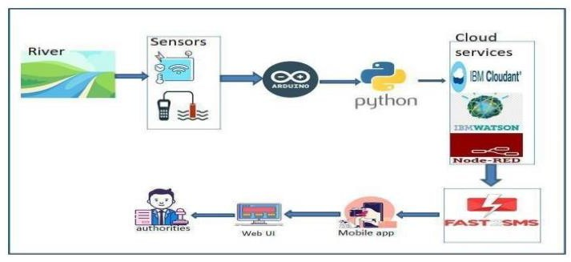

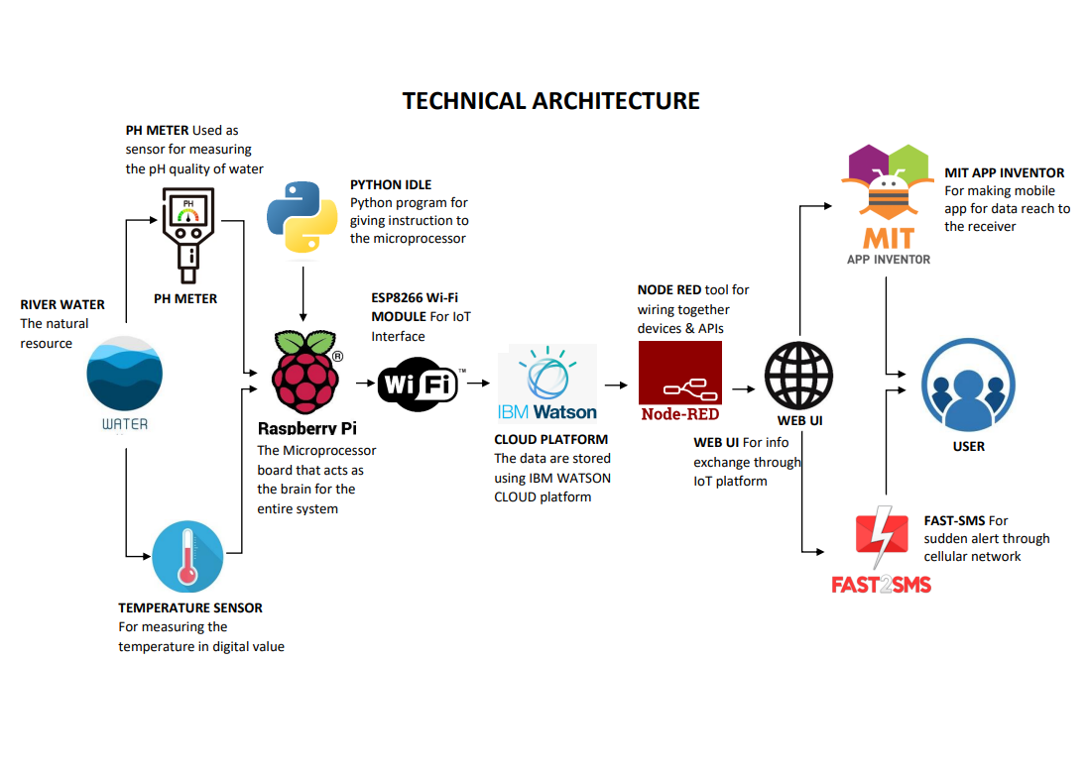

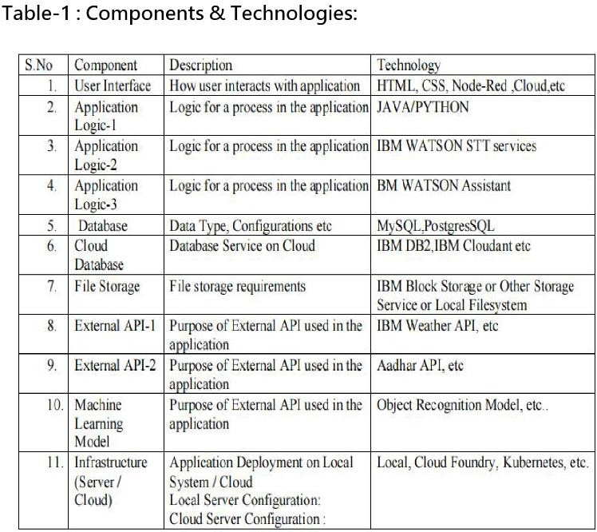

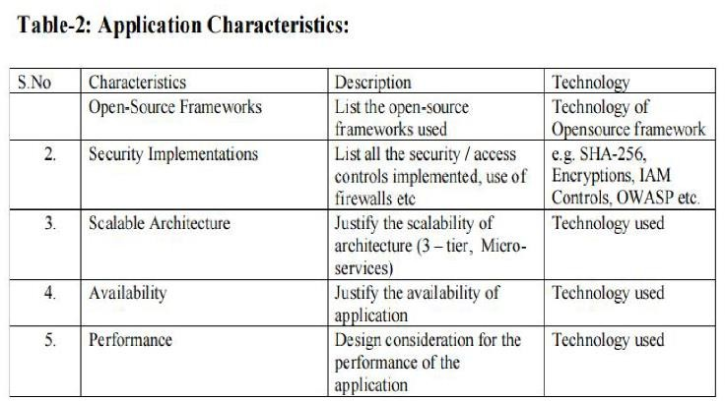

* 1. **PROJECT PLANNING AND SCHEDULING**

# 6.2 SPRINT DELIVERY SCHEDULE

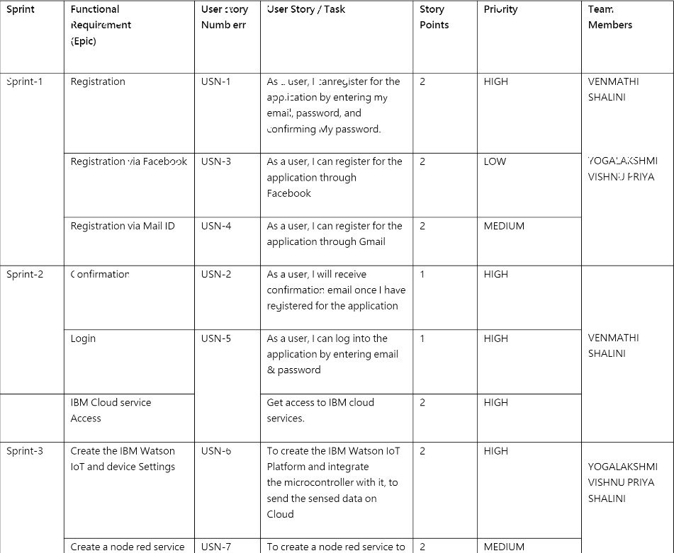

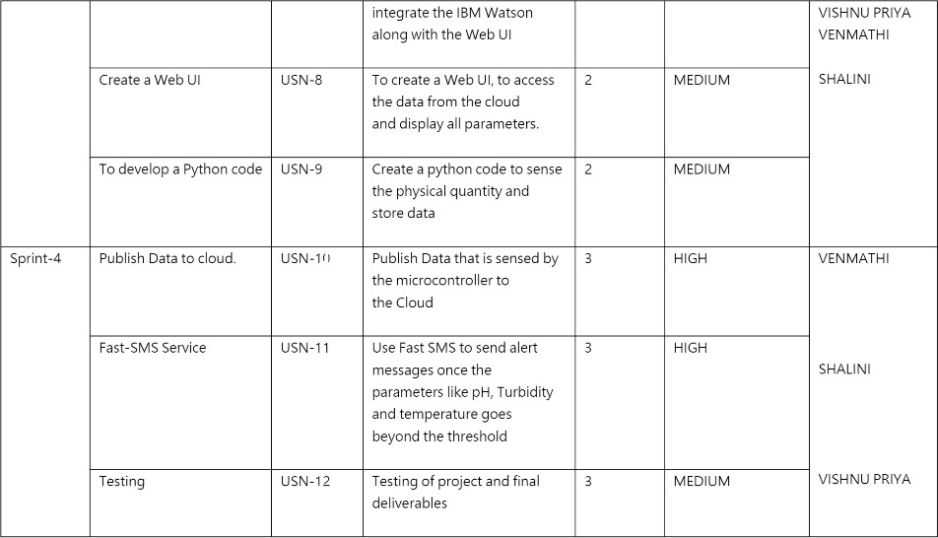

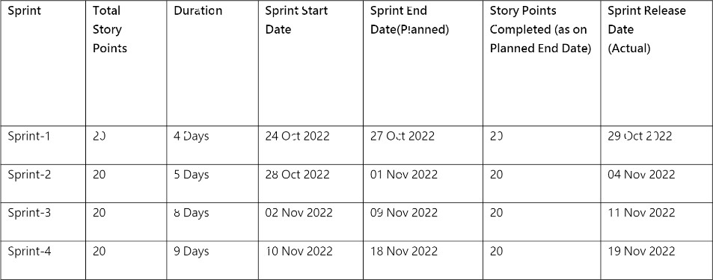

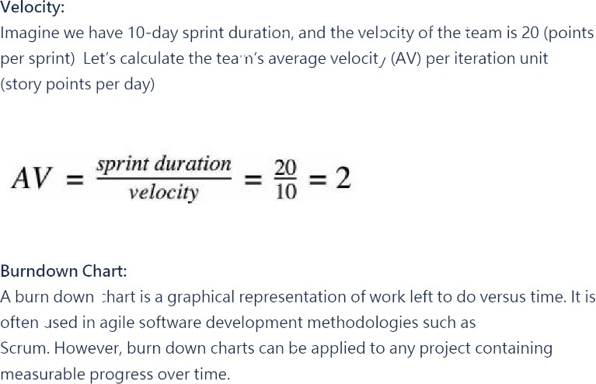

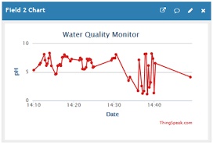

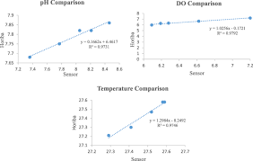

* 1. **CODING AND SOLUTIONING**

# 7.1 NODE RED SERVICE ASSOCIATED WITH IBM CLOUD:

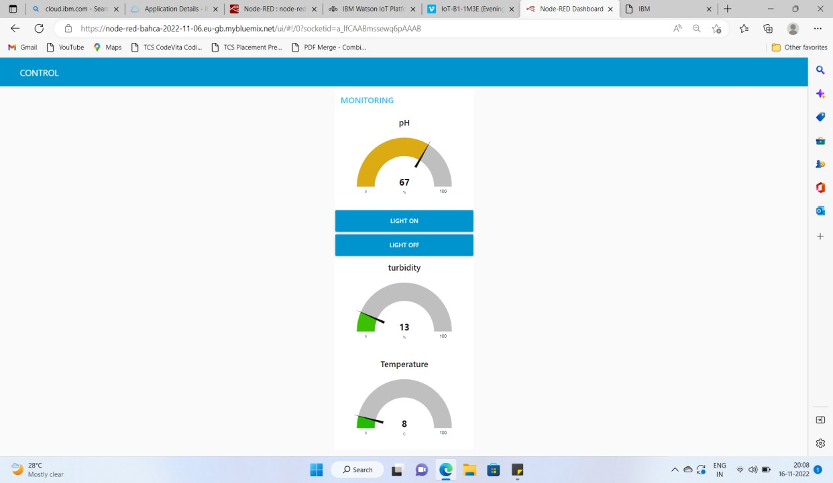**NODE-RED TO CREATE UI**

# ADVANTAGES:

* The prototype developed for water quality maintenance is very beneficial for safeguarding public health and also adds to the clean environment.
* The automation of this water monitoring, cleaning and control process removes the need of

manual labor and thus saves time and money.

* The automation of the system makes the control and monitoring process more efficient and effective. Real time monitoring on mobile phone which is possible through the interface of plc with Arduino and Bluetooth module allows remote controlling of the system

# DISADVANTAGES:

* It is difficult to collect the water samples from all the area of the water body. ● The cost of

analysis is very high.

* The lab testing and analysis takes some time and hence the lab results does not reflect real

time water quality measurement due to delay in measurement.

* The process is time consuming due to slow process of manual data collection from different

locations of the water body.

* The method is prone to human errors of various forms.

# PROJECT CODE OUTOUT:

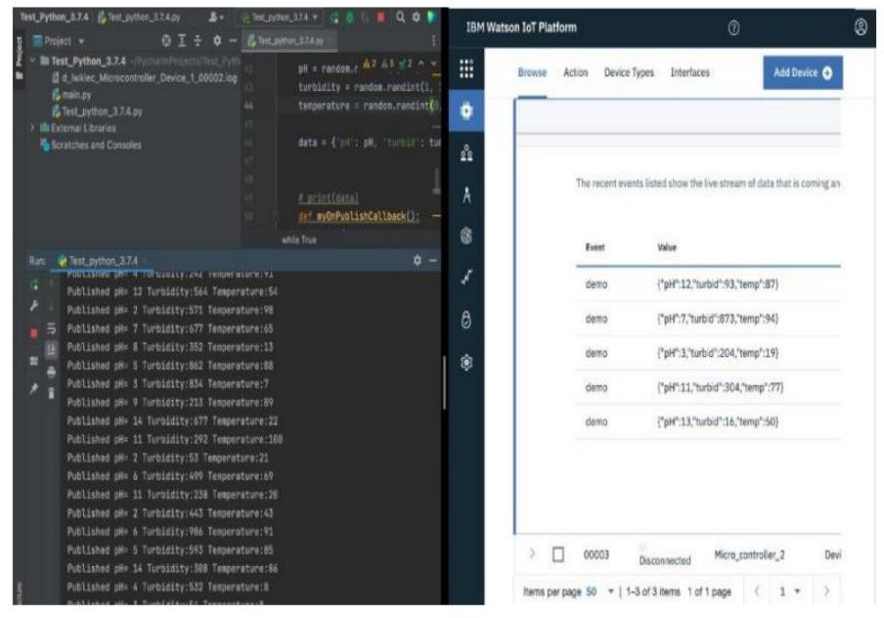

**MIT APP OUTPUT**

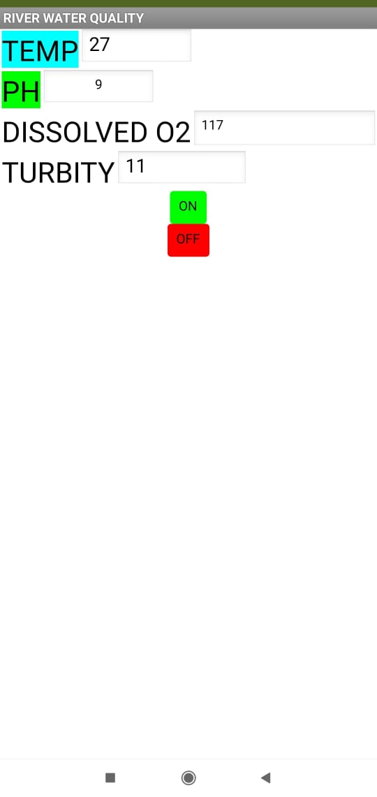

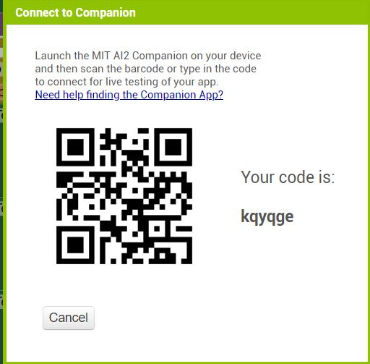

## 13.2 GIT-HUB LINK:

**https://github.com/IBM-EPBL/IBM-Project-11941-1659359473**

## DEMO VIDEO LINK